Reg. No: 

Programme : B. E / B. tech
Course Code : CSA43
Course Name : Internet programming
Problem Statement (Assignment) Max Marks: 100
Field | Content
Assignment Title | Web-Based Intelligent Campus Complaint Management and Resolution System
Course Outcome(s) – CO | CO1: Develop visually appealing web pages using CSS for layout and style, and create dynamic, interactive functionality with JavaScript.  CO2: Build dynamic web applications using XML, XSLT, and JSP within the MVC paradigm for efficient data handling and presentation.
Bloom’s Taxonomy Level | L3 – Apply | L4 – Analyze | L5 – Evaluate | L6 – Create
SDG Mapping (SDG 1–17) | SDG 9 - Industry, Innovation and Infrastructure, SDG 4 -  Quality Education
Problem Statement
A university currently relies on manual communication such as emails, phone calls, and paper-based records for reporting and resolving campus service issues. This approach makes it difficult to efficiently record complaints, assign requests to the appropriate service personnel, monitor progress, and provide timely status updates to students and faculty.

The university therefore proposes to develop a Web-Based Intelligent Campus Complaint Management and Resolution System as an integrated web-based application. The system shall enable students and faculty to submit service requests related to laboratory equipment faults, network problems, classroom maintenance, library services, and other technical issues through a web browser. Users should be able to provide relevant details, submit requests, and subsequently track the status of their requests.
The proposed system should demonstrate an integrated client-server web architecture. The client side shall provide an interactive and user-friendly interface using HTML/XHTML, CSS, JavaScript, and DOM. The server side shall process requests using Java Servlets and JSP, following the MVC architecture. XML shall be used for structured data representation, and XSLT shall be used to transform XML data for presentation where appropriate.

Problem Identification (10 Marks)-The university relies on manual communication (emails, phone calls, paper records) for reporting and resolving service issues, which causes inefficiency in recording complaints, assigning requests, monitoring progress, and providing timely updates.
Proposed Solution -Develop a Smart Campus Service Management System (10 Marks), a web-based application that allows students and faculty to submit service requests (lab equipment faults, network problems, classroom maintenance, library services) and track their status online.
System Design & Architecture - Data Representation (20 Marks) -Implement an integrated client-server web architecture. The client side should use HTML/XHTML, CSS, JavaScript, and DOM for interactivity, while the server side should use Java Servlets and JSP following the MVC model. Use XML for structured data representation for transforming XML data into user-friendly formats for presentation and reporting.
Implementation & Testing (10 Marks) -Demonstrate request submission, assignment to service personnel, progress tracking, and timely updates. Validate inputs, handle errors, and ensure smooth user experience.

STG Goals –SDG 9 - Industry, Innovation and Infrastructure, SDG 4 - Quality Education

Requirement Analysis (SDG 9 – Industry, Innovation & Infrastructure) Identify inefficiencies in manual reporting and propose a digital infrastructure for service management.
Client Interface Development (SDG 4 – Quality Education) Build user-friendly web forms and dashboards so students/faculty can easily submit and track requests, improving access to campus services.
Assessment Criterion | CO Mapping | Weightage / Marks
Problem understanding & formulation | CO1 | 10
Application of course/domain knowledge | CO2 | 20
Solution methodology / design / implementation | CO3 | 20
Use of appropriate modern tools / techniques | CO4 | 10
Results, testing & validation | CO4 / CO5 | 15
Analysis, trade-offs & justification | CO5 | 15
Broader considerations / professional responsibility, where applicable | CO5 | 5
Technical documentation & reflection | CO1–CO5 | 5
TOTAL |  | 100

Performance Level | CO Attainment Percentage | Interpretation
Level 3 | ≥ 70% | CO Attained
Level 2 | 60–69% | CO Moderately Attained
Level 1 | 50–59% | CO Minimally Attained
Level 0 | < 50% | CO Not Attained

Code of Conduct
I Sanjay kumar soy (192311151) (Name / Reg. No.) certify that this submission is my original work and that I have adhered to the guidelines specified for this assessment. I understand that any violation of academic-integrity rules will result in disciplinary action.

Signature of the Student: 
_____________________  Faculty In-charge  Name: dr m sathyamoorthy  Date: | _____________________  Course Coordinator  Name: dr marie claude  Date: | _____________________  Head of Department  Name: dr anusuya  Date:

1. Title
Web-Based Intelligent Campus Complaint Management and Resolution System
2. Introduction
Universities handle various campus service issues such as laboratory equipment faults, network problems, classroom maintenance, library services, and other technical issues. In many cases, these issues are reported through emails, phone calls, or paper-based records. Such manual methods can make it difficult to maintain complaint records, assign issues to the appropriate service personnel, monitor progress, and provide timely updates to students and faculty.
To overcome these limitations, the Web-Based Intelligent Campus Complaint Management and Resolution System is proposed as a centralized web application. The system allows students and faculty to submit service requests through a web browser and track the status of their complaints online. Service personnel can manage the submitted requests, update their progress, and work towards resolving the reported issues.
The system demonstrates an integrated client-server web architecture. The client side uses HTML/XHTML, CSS, JavaScript, and DOM to provide an interactive user interface. The server side uses Java Servlets and JSP following the MVC architecture for processing requests and generating dynamic content. XML is used for structured data representation, while XSLT can be used to transform XML data into a user-friendly presentation.
The main goal of this system is to make campus complaint management more organized, efficient, transparent, and easier to track, while demonstrating the practical application of Internet Programming concepts.
3. Problem Identification
The university currently uses manual methods such as emails, phone calls, and paper-based records to report and resolve campus service issues. This approach creates difficulties in efficiently managing complaints and providing timely services to students and faculty.
The major problems identified are:
- Manual Complaint Reporting – Students and faculty depend on emails, phone calls, or paper records to report campus issues.
- Difficulty in Recording Complaints – Maintaining complaint details manually can make it difficult to organize and retrieve records.
- Difficulty in Assigning Requests – Complaints may not be quickly assigned to the appropriate service personnel.
- Lack of Progress Monitoring – Users may have difficulty knowing whether their complaint has been received, assigned, or resolved.
- Delayed Status Updates – The manual process makes it difficult to provide students and faculty with timely information about their requests.
- Inefficient Resolution Process – Without a centralized system, managing issues such as laboratory equipment faults, network problems, classroom maintenance, library services, and technical issues can become inefficient.
Problem Summary
Therefore, the existing manual complaint-handling process needs to be replaced or improved with a centralized web-based system that can efficiently record complaints, assign them to service personnel, monitor their progress, and allow users to track the status of their requests.
4. Proposed Solution
The proposed solution is a Web-Based Intelligent Campus Complaint Management and Resolution System. It is designed to provide a centralized platform for students and faculty to report campus service issues and track their complaints online.
The system will allow users to submit service requests related to laboratory equipment faults, network problems, classroom maintenance, library services, and other technical issues through a web browser.
Main Features of the Proposed Solution
- Online Complaint Submission
Users can submit complaints by entering the required details through a web-based form.
- Complaint Management
The system maintains complaint information in a structured manner, making it easier to manage and retrieve requests.
- Complaint Assignment
Submitted complaints can be assigned to the appropriate service personnel for further action.
- Status Tracking
Users can track the progress of their complaints and know whether the request is being processed or resolved.
- Status Updates
Service personnel can update the status of complaints so that users receive timely information.
- Interactive User Interface
HTML/XHTML, CSS, JavaScript, and DOM will be used to create an interactive and user-friendly client-side interface.
- Server-Side Processing
Java Servlets and JSP will handle requests and responses on the server side using the MVC architecture.
- XML and XSLT Integration
XML will be used for structured data representation, while XSLT will be used to transform XML data into a suitable presentation format.
Proposed Workflow
Student/Faculty → Submit Complaint → Server Processes Request → Complaint Recorded → Assigned to Service Personnel → Status Updated → User Tracks Status → Complaint Resolved
Expected Result
The proposed system will provide a centralized, organized, and efficient method for managing campus complaints. It will reduce dependence on manual communication, improve complaint tracking, and provide a practical demonstration of the Internet Programming technologies required for the assignment.
5. System Requirements
The Web-Based Intelligent Campus Complaint Management and Resolution System requires both hardware and software resources to develop, run, and test the web application.

5.1 Hardware Requirements
Component | Minimum Requirement
Processor | Intel Core i3 or equivalent
RAM | 4 GB or above
Storage | 10 GB of available space
Display | 1366 × 768 resolution or higher
Network | LAN/Wi-Fi connection
Input Devices | Keyboard and Mouse
5.2 Software Requirements
Software | Requirement / Purpose
Operating System | Windows / Linux / macOS
Web Browser | Google Chrome, Mozilla Firefox, or Microsoft Edge
HTML/XHTML | Designing the web pages
CSS | Styling and page layout
JavaScript | Client-side interaction and validation
DOM | Dynamic manipulation of HTML elements
XML | Structured representation of complaint data
XSLT | Transformation and presentation of XML data
Java | Server-side application development
JSP | Creating dynamic web pages
Java Servlets | Processing client requests and server responses
Apache Tomcat | Servlet/JSP web server
IDE | Visual Studio Code / Eclipse / IntelliJ IDEA
5.3 Functional Requirements
The system should provide the following functions:
- Users should be able to submit complaints/service requests.
- The system should record the submitted complaint details.
- Complaints should be assigned to appropriate service personnel.
- Service personnel should be able to update complaint status.
- Users should be able to track the status of their complaints.
- The system should validate user inputs and handle invalid requests.
- XML should support structured data representation.
- JSP and Servlets should process requests and generate dynamic responses.
5.4 Non-Functional Requirements
- Usability: The interface should be simple and easy to understand.
- Performance: Requests should be processed within a reasonable time.
- Reliability: Complaint information should be handled consistently.
- Maintainability: The application should be organized using separate components following the MVC approach.
- Security: User input should be validated to reduce invalid or harmful data.
- Compatibility: The application should work with commonly used modern web browsers.
These requirements support the assignment's requirement for an integrated client-server web application using HTML/XHTML, CSS, JavaScript, DOM, XML, XSLT, JSP, and Servlets.
6. System Architecture / Design
The Web-Based Intelligent Campus Complaint Management and Resolution System follows an integrated client-server web architecture. The client side provides the user interface, while the server side processes requests and manages the application logic. The assignment specifically requires the server side to use Java Servlets and JSP following the MVC architecture, with XML and XSLT for structured data representation and presentation.
6.1 Architecture
The system can be divided into the following layers:
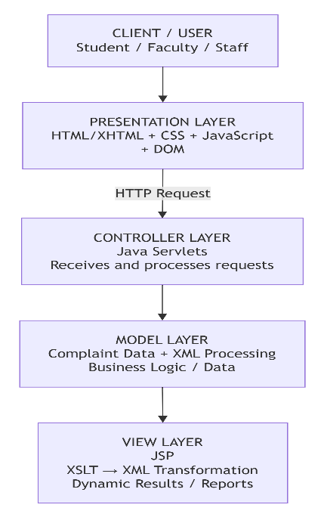
6.2 Working of the System
- User Access
A student or faculty member accesses the application using a web browser.
- User Interface
HTML/XHTML and CSS provide the structure and appearance of the web pages.
- Client-Side Interaction
JavaScript and DOM are used for input validation and interactive page elements.
- Request Processing
When a user submits a complaint, the request is sent to the server through HTTP.
- Servlet Processing
The Java Servlet acts as the controller and processes the incoming request.
- Data Handling
Complaint information is represented in a structured format using XML.
- Presentation
JSP generates dynamic web content, while XSLT can transform XML data into a user-friendly presentation.
- Response to User
The processed result is returned to the user's browser, allowing the user to view the submitted complaint or its current status.
6.3 MVC Design
The system follows the Model-View-Controller (MVC) approach:
MVC Component | Technology | Responsibility
Model | Java / XML | Manages complaint data and application logic
View | JSP / HTML / CSS | Displays information to the user
Controller | Java Servlets | Receives requests and controls application flow
This architecture separates the user interface, application processing, and data handling, making the system easier to understand, maintain, and extend.

7. Modules of the System
The Web-Based Intelligent Campus Complaint Management and Resolution System can be divided into several modules. Each module performs a specific function and together they provide a complete complaint management process.
7.1 User Module
This module is used by students and faculty members to interact with the system.
Functions:
- Access the complaint management system.
- Enter user details.
- Submit a new complaint.
- View submitted complaints.
- Track the status of complaints.
7.2 Complaint Submission Module
This module allows users to report campus-related problems through an online form.
Functions:
- Select the complaint category.
- Enter the complaint description.
- Provide relevant details.
- Validate the entered information.
- Submit the complaint to the server.
Example complaint categories:
- Laboratory equipment
- Network problems
- Classroom maintenance
- Library services
- Other technical issues
7.3 Complaint Management Module
This module handles the complaints received from students and faculty.
Functions:
- Receive submitted complaints.
- Maintain complaint details.
- Generate a complaint/reference ID.
- View pending complaints.
- Organize complaints based on their category and status.
7.4 Service Personnel Module
This module is used by the responsible staff to handle complaints.
Functions:
- View assigned complaints.
- Examine complaint details.
- Accept and work on complaints.
- Update the progress of complaints.
- Mark completed complaints as resolved.
7.5 Complaint Tracking Module
This module allows users to monitor the progress of their submitted complaints.
The complaint can have different statuses such as:
Submitted
↓
Assigned
↓
In Progress
↓
Resolved
Users can use their complaint/reference ID to check the current status.
7.6 Notification / Status Update Module
This module provides updated information about complaints.
Functions:
- Display the current complaint status.
- Show progress information.
- Inform users when a complaint has been resolved.
- Provide timely updates about service requests.
7.7 XML and XSLT Data Module
This module demonstrates the use of XML and XSLT, which are specifically required in the assignment.
XML is used to represent complaint information in a structured format.
Example:
<complaint>
<id>C001</id>
<category>Network Problem</category>
<description>Internet connection is not working</description>
<status>In Progress</status>
</complaint>
XSLT can transform this XML data into an HTML-style presentation that is easier for users to read.
7.8 JSP and Servlet Module
This module handles the server-side functionality of the application.
- Servlets act as controllers that receive requests and process application logic.
- JSP is used to generate dynamic web pages and display the results.
- Together, they support the MVC-based design required for the application.
Module Flow
User Module
↓
Complaint Submission
↓
Servlet Processing
↓
Complaint Management
↓
Service Personnel
↓
Status Update
↓
Complaint Tracking
↓
User
These modules work together to provide a complete workflow from complaint submission to complaint resolution and tracking.

8. Technologies Used
The proposed system uses the Internet Programming technologies specified in the assignment: HTML/XHTML, CSS, JavaScript, DOM, XML, XSLT, JSP, and Servlets.
8.1 HTML / XHTML
HTML (HyperText Markup Language) is used to create the basic structure of the web application.
In this project, HTML/XHTML is used for:
- Creating complaint submission forms.
- Creating buttons, input fields, tables, and navigation elements.
- Structuring dashboard and complaint-tracking pages.
- Displaying information to users.
Example:
<form action="submitComplaint" method="post">
<label>Complaint Category:</label>
<select name="category">
<option>Network Problem</option>
<option>Classroom Maintenance</option>
<option>Laboratory Equipment</option>
</select>
<label>Description:</label>
<textarea name="description"></textarea>
<button type="submit">Submit Complaint</button>
</form>
8.2 CSS
CSS (Cascading Style Sheets) is used to control the appearance and layout of the application.
It is used for:
- Page layout.
- Colors and fonts.
- Buttons and forms.
- Complaint status indicators.
- Dashboard design.
- Responsive presentation.
Example:
body {
font-family: Arial, sans-serif;
margin: 0;
background: #f4f6f8;
}
button {
padding: 10px 20px;
border: none;
cursor: pointer;
}
8.3 JavaScript
JavaScript provides client-side interactivity and validation.
In this system, JavaScript can be used to:
- Validate complaint forms.
- Check whether required fields are filled.
- Display messages to users.
- Provide interactive buttons and controls.
- Improve the user experience.
Example:
function validateComplaint() {
let description = document.getElementById("description").value;

if (description.trim() === "") {
alert("Please enter the complaint description.");
return false;
}

return true;
}
8.4 DOM
DOM (Document Object Model) represents an HTML document as a collection of objects that JavaScript can access and modify.
In this project, DOM can be used to:
- Read values from form fields.
- Change complaint status dynamically.
- Display messages.
- Update page elements without rewriting the entire page.
Example:
document.getElementById("status").innerHTML = "In Progress";
Here, JavaScript accesses the HTML element using its ID and changes its displayed content.
8.5 XML
XML (Extensible Markup Language) is used for structured representation of complaint information.
Example:
<complaints>
<complaint>
<id>C001</id>
<category>Network Problem</category>
<description>Internet connection is not working</description>
<status>In Progress</status>
</complaint>
</complaints>
XML provides a structured format for representing and exchanging complaint-related information.

8.6 XSLT
XSLT (Extensible Stylesheet Language Transformations) is used to transform XML data into a presentation format such as HTML.
For example, XML complaint data can be transformed into a table:
<xsl:template match="/">
<html>
<body>
<table border="1">
<tr>
<th>Complaint ID</th>
<th>Category</th>
<th>Status</th>
</tr>

<xsl:for-each select="complaints/complaint">
<tr>
<td><xsl:value-of select="id"/></td>
<td><xsl:value-of select="category"/></td>
<td><xsl:value-of select="status"/></td>
</tr>
</xsl:for-each>
</table>
</body>
</html>
</xsl:template>
Thus, XSLT helps convert structured XML information into a user-friendly format.
8.7 JSP
JSP (JavaServer Pages) is used to create dynamic web pages on the server side.
In this project, JSP can be used to:
- Display submitted complaint information.
- Display complaint status.
- Generate dynamic dashboard content.
- Present responses received from Servlets.
Example:
<h2>Complaint Details</h2>

<p>Complaint ID: ${complaint.id}</p>
<p>Category: ${complaint.category}</p>
<p>Status: ${complaint.status}</p>
8.8 Servlets
Java Servlets are used to process HTTP requests and responses on the server.
In this system, Servlets can:
- Receive complaint form submissions.
- Process user requests.
- Validate submitted information.
- Create and update complaint records.
- Forward results to JSP pages.
Example:
@WebServlet("/submitComplaint")
public class ComplaintServlet extends HttpServlet {
protected void doPost(HttpServletRequest request,
HttpServletResponse response)
throws ServletException, IOException {
String category = request.getParameter("category");
String description = request.getParameter("description");

request.setAttribute("category", category);
request.setAttribute("description", description);
request.getRequestDispatcher("result.jsp")
.forward(request, response);
}
}
8.9 Technology Integration
The technologies work together as follows:
HTML/XHTML + CSS
↓
JavaScript + DOM
↓
HTTP Request
↓
Java Servlet
↓
Application Logic
↓
XML Data
↓
JSP / XSLT
↓
HTML Response
↓
User
This integration demonstrates the client-server architecture and MVC-based approach required for the assignment.

9. Implementation / Source Code
The Web-Based Intelligent Campus Complaint Management and Resolution System is implemented as a client-server web application. The implementation combines HTML/XHTML, CSS, JavaScript, DOM, XML, XSLT, JSP, and Java Servlets.
9.1 Project Structure
CampusComplaintSystem/
│
├── index.html
├── complaint.html
├── dashboard.jsp
├── status.jsp
│
├── css/
│ └── style.css
│
├── js/
│ └── validation.js
│
├── xml/
│ └── complaints.xml
│
├── xslt/
│ └── complaints.xsl
│
└── src/
└── ComplaintServlet.java
9.2 Complaint Submission Page – HTML
The complaint form allows students and faculty to enter their complaint details.
<!DOCTYPE html>
<html>
<head>
<title>Campus Complaint Management</title>
<link rel="stylesheet" href="css/style.css">
</head>

<body>

<div class="container">

<h1>Campus Complaint Management System</h1>

<form action="submitComplaint" method="post"
onsubmit="return validateComplaint()">

<label>Name</label>
<input type="text" id="name" name="name" required>

<label>Complaint Category</label>
<select name="category" required>
<option value="">Select Category</option>
<option>Laboratory Equipment</option>
<option>Network Problem</option>
<option>Classroom Maintenance</option>
<option>Library Service</option>
<option>Other Technical Issue</option>
</select>

<label>Description</label>
<textarea id="description"
name="description"
rows="5"
required></textarea>

<button type="submit">Submit Complaint</button>

</form>

</div>

<script src="js/validation.js"></script>

</body>
</html>
9.3 CSS – Page Design
CSS is used to provide a clean and user-friendly interface.
body {
font-family: Arial, sans-serif;
background: #f4f6f8;
margin: 0;
}

.container {
width: 600px;
margin: 50px auto;
padding: 25px;
background: white;
border-radius: 10px;
}

h1 {
text-align: center;
}

label {
display: block;
margin-top: 15px;
font-weight: bold;
}

input, select, textarea {
width: 100%;
padding: 10px;
margin-top: 5px;
box-sizing: border-box;
}

button {
margin-top: 20px;
padding: 10px 20px;
cursor: pointer;
}
9.4 JavaScript and DOM Validation
JavaScript validates the complaint before it is submitted to the server. DOM is used to access the HTML elements.
function validateComplaint() {

let name = document.getElementById("name").value;
let description =
document.getElementById("description").value;

if (name.trim() === "") {
alert("Please enter your name.");
return false;
}

if (description.trim() === "") {
alert("Please enter the complaint description.");
return false;
}

return true;
}
The getElementById() method demonstrates DOM manipulation, while JavaScript performs client-side validation.
9.5 Java Servlet
The Servlet receives the complaint submitted from the HTML form and processes the request.
import java.io.IOException;
import jakarta.servlet.ServletException;
import jakarta.servlet.annotation.WebServlet;
import jakarta.servlet.http.HttpServlet;
import jakarta.servlet.http.HttpServletRequest;
import jakarta.servlet.http.HttpServletResponse;

@WebServlet("/submitComplaint")
public class ComplaintServlet extends HttpServlet {

protected void doPost(HttpServletRequest request,
HttpServletResponse response)
throws ServletException, IOException {

String name = request.getParameter("name");
String category = request.getParameter("category");
String description =
request.getParameter("description");

request.setAttribute("name", name);
request.setAttribute("category", category);
request.setAttribute("description", description);
request.setAttribute("status", "Submitted");

request.getRequestDispatcher("dashboard.jsp")
.forward(request, response);
}
}
Servlet Processing
HTML Form
↓
HTTP POST Request
↓
ComplaintServlet
↓
Read Form Data
↓
Process Complaint
↓
Set Attributes
↓
Forward to JSP
9.6 JSP Dashboard
JSP is used to display the complaint information dynamically.
<!DOCTYPE html>
<html>
<head>
<title>Complaint Dashboard</title>
</head>

<body>

<h1>Complaint Dashboard</h1>

<table border="1">

<tr>
<th>Name</th>
<th>Category</th>
<th>Description</th>
<th>Status</th>
</tr>

<tr>
<td>${name}</td>
<td>${category}</td>
<td>${description}</td>
<td>${status}</td>
</tr>

</table>

</body>
</html>
The JSP page receives the attributes from the Servlet and displays them to the user.
9.7 XML Data
XML is used to represent complaint information in a structured format.
<?xml version="1.0" encoding="UTF-8"?>

<complaints>

<complaint>
<id>C001</id>
<name>Student</name>
<category>Network Problem</category>
<description>
Internet connection is not working
</description>
<status>In Progress</status>
</complaint>

<complaint>
<id>C002</id>
<name>Faculty</name>
<category>Classroom Maintenance</category>
<description>
Projector is not working
</description>
<status>Resolved</status>
</complaint>
</complaints>
9.8 XSLT Transformation
XSLT transforms the XML complaint data into an HTML table.
<?xml version="1.0" encoding="UTF-8"?>
<xsl:stylesheet version="1.0"
xmlns:xsl="http://www.w3.org/1999/XSL/Transform">
<xsl:template match="/">
<html>
<body>
<h2>Complaint Records</h2>
<table border="1">
<tr>
<th>Complaint ID</th>
<th>Name</th>
<th>Category</th>
<th>Status</th>
</tr>
<xsl:for-each select="complaints/complaint">
<tr>
<td><xsl:value-of select="id"/></td>
<td><xsl:value-of select="name"/></td>
<td><xsl:value-of select="category"/></td>
<td><xsl:value-of select="status"/></td>
</tr>
</xsl:for-eac
</table>
</body>
</html>
</xsl:template>
</xsl:stylesheet>
9.9 Implementation Flow
The complete implementation works in the following sequence:
User
↓
HTML/XHTML Form
↓
CSS Interface
↓
JavaScript + DOM Validation
↓
HTTP Request
↓
Java Servlet
↓
Complaint Processing
↓
XML Data
↓
JSP / XSLT
↓
Complaint Dashboard
↓
Status Tracking
This implementation demonstrates the integration of the required Internet Programming technologies into a practical campus complaint management application, rather than presenting only theoretical concepts.

10. Output Screenshots
This section demonstrates the actual output of the Web-Based Intelligent Campus Complaint Management and Resolution System after implementation.
10.1 Complaint Submission Page
The complaint submission page provides a form through which students or faculty can enter their name, select the complaint category, describe the issue, and submit the request.
Screenshot to
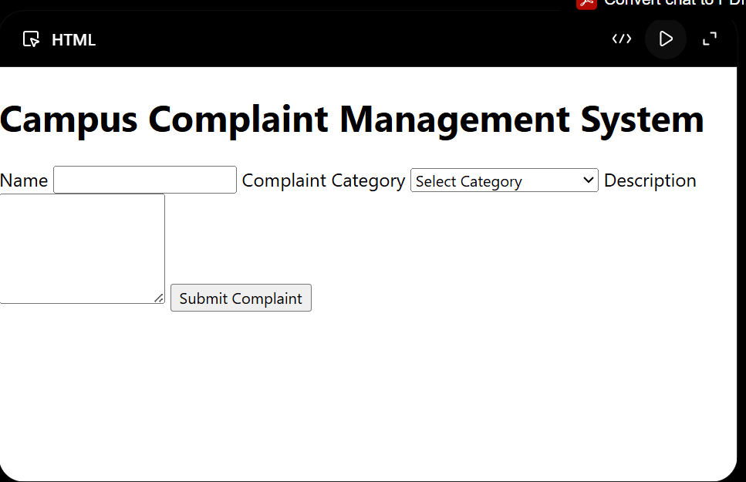
Expected output:
The page should display:
- Campus Complaint Management System heading
- Name field
- Complaint Category field
- Description field
- Submit Complaint button
10.2 Complaint Dashboard
After submitting a complaint, the system processes the request through the Servlet and displays the complaint information on the dashboard using JSP.
Screenshot to include:
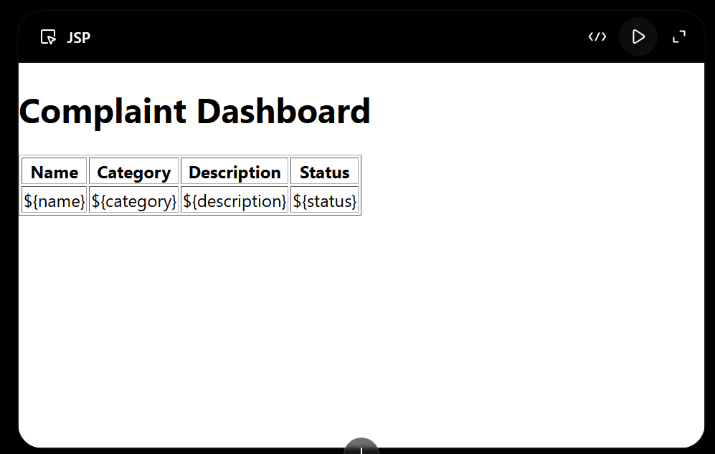
Expected output:
Name | Category | Description | Status
Student | Network Problem | Internet connection is not working | Submitted
The dashboard allows the user to verify that the complaint has been successfully recorded.
10.3 Complaint Status Tracking
The status tracking page displays the current progress of a submitted complaint.
Example status flow:
Submitted
↓
Assigned
↓
In Progress
↓
Resolved
The user can identify the current stage of the complaint and determine whether the issue has been resolved.

10.4 XML/XSLT Output
The XML file stores complaint information in a structured format, while XSLT transforms the XML data into a readable HTML-style table.
Screenshot to include:
📷 Screenshot of XML/XSLT transformed complaint records
Example:
Complaint ID | Name | Category | Status
C001 | Student | Network Problem | In Progress
C002 | Faculty | Classroom Maintenance | Resolved
10.5 Overall Output
The screenshots demonstrate that the implemented application supports the complete basic workflow:
Submit Complaint → Process Request → Display Complaint → Track Status → Resolve Complaint
These outputs provide practical evidence that the proposed system has been implemented and that the required Internet Programming technologies are being applied.

11. Testing and Validation
Testing is performed to verify that the Web-Based Intelligent Campus Complaint Management and Resolution System works correctly and satisfies the required functionality. The assignment specifically requires validation of request submission, assignment to service personnel, progress tracking, timely updates, input validation, and error handling.
11.1 Test Cases
Test Case | Test Scenario | Expected Result | Actual Result | Status
TC01 | Open the application | Home/complaint page should load successfully | Page loaded successfully | Pass
TC02 | Submit a complaint with valid details | Complaint should be submitted successfully | Complaint submitted | Pass
TC03 | Submit complaint without name | System should display validation message | Validation message displayed | Pass
TC04 | Submit complaint without description | System should prevent submission and request description | Validation message displayed | Pass
TC05 | Select complaint category | Selected category should be accepted | Category accepted | Pass
TC06 | Submit complaint to Servlet | Servlet should receive and process the request | Request processed successfully | Pass
TC07 | Display complaint in JSP | Complaint details should appear on dashboard | Details displayed correctly | Pass
TC08 | Display complaint status | Current status should be shown | Status displayed as Submitted | Pass
TC09 | Update complaint status | Updated status should be displayed to the user | Status updated successfully | Pass
TC10 | Display XML complaint data | XML should contain structured complaint information | XML data displayed correctly | Pass
TC11 | Apply XSLT transformation | XML data should be converted into a readable format | Data displayed as a table | Pass
TC12 | Enter invalid/empty input | System should reject invalid input | Invalid input rejected | Pass
11.2 Validation
The system is validated at different levels:
1. Input Validation
JavaScript checks whether required fields such as the name and complaint description have been entered before submitting the form.
2. Client-Side Validation
DOM is used to access form elements and provide immediate feedback to the user.
3. Server-Side Validation
The Java Servlet receives the request and processes the submitted complaint information.
4. Data Validation
XML provides a structured representation of complaint records.
5. Output Validation
JSP displays the processed complaint information, while XSLT transforms XML data into a readable presentation.
11.3 Testing Result
The test cases demonstrate that the major functions of the proposed system operate as expected. The system successfully supports the basic workflow of:
Complaint Submission → Request Processing → Complaint Display → Status Update → Status Tracking
Therefore, the implemented prototype satisfies the major functional requirements specified for the assignment.
12. Advantages of the System
The Web-Based Intelligent Campus Complaint Management and Resolution System provides several advantages over the existing manual complaint-handling process.
12.1 Easy Complaint Submission
Students and faculty can submit complaints through a web browser without depending on emails, phone calls, or paper-based communication.
12.2 Centralized Complaint Management
All complaint information can be managed through a single system, making it easier to record, organize, and access service requests.
12.3 Faster Complaint Assignment
Complaints can be assigned to the appropriate service personnel, helping the responsible staff identify and handle issues more efficiently.
12.4 Complaint Status Tracking
Users can check the progress of their complaints and know whether a request is Submitted, Assigned, In Progress, or Resolved.
12.5 Timely Updates
The system allows complaint status to be updated digitally, reducing the need for users to repeatedly contact university staff for information.
12.6 Reduced Paperwork
Since complaints are submitted and managed digitally, the system reduces dependence on paper-based records and manual documentation.
12.7 Improved Transparency
Users can view the current status of their requests, making the complaint-resolution process more transparent.
12.8 User-Friendly Interface
The use of HTML/XHTML, CSS, JavaScript, and DOM helps create an interactive and easy-to-use interface.
12.9 Better Data Organization
Using XML provides a structured way to represent complaint information, while XSLT can transform the data into a readable format.
12.10 Demonstrates Internet Programming Concepts
The system integrates HTML/XHTML, CSS, JavaScript, DOM, XML, XSLT, JSP, and Java Servlets into a single practical application, fulfilling the technical requirements of the assignment.
Summary
Overall, the proposed system makes campus complaint management more organized, accessible, transparent, and efficient while reducing the limitations of the existing manual process.

13. SDG Mapping
The proposed Web-Based Intelligent Campus Complaint Management and Resolution System contributes to the United Nations Sustainable Development Goals (SDGs) identified in the assignment, particularly SDG 9 – Industry, Innovation and Infrastructure and SDG 4 – Quality Education.
13.1 SDG 9 – Industry, Innovation and Infrastructure
SDG 9: Build resilient infrastructure, promote inclusive and sustainable industrialization and foster innovation.
The system supports SDG 9 by introducing a digital infrastructure for campus service management. Instead of depending on manual communication, the proposed application provides a centralized web-based platform for reporting, assigning, monitoring, and resolving campus service issues.
Contribution of the system:
- Digitizes the campus complaint-handling process.
- Reduces dependence on paper-based records.
- Provides centralized service-request management.
- Uses web technologies to improve operational efficiency.
- Demonstrates the application of digital innovation to campus infrastructure management.
The assignment specifically identifies requirement analysis and digital infrastructure for service management as part of its SDG 9 mapping.
13.2 SDG 4 – Quality Education
SDG 4: Ensure inclusive and equitable quality education and promote lifelong learning opportunities for all.
A well-maintained campus environment supports students and faculty in their educational activities. The system provides an easier way to report problems affecting laboratories, classrooms, networks, libraries, and other campus facilities.
Contribution of the system:
- Makes campus service reporting more accessible.
- Helps students and faculty report issues easily.
- Enables users to track the progress of their requests.
- Supports faster identification of problems affecting learning facilities.
- Improves access to campus support services.
The assignment specifically maps client interface development and user-friendly web forms/dashboards to SDG 4.
13.3 SDG Mapping Summary
SDG | Goal | Contribution of the System
SDG 9 | Industry, Innovation and Infrastructure | Provides digital infrastructure for centralized campus complaint and service management.
SDG 4 | Quality Education | Improves access to campus services and helps maintain facilities that support education.

14. Conclusion
The Web-Based Intelligent Campus Complaint Management and Resolution System provides an efficient solution for managing campus service complaints. The proposed system replaces the limitations of manual communication methods such as emails, phone calls, and paper-based records with a centralized web-based platform.
The system enables students and faculty to submit service requests, track complaint status, and receive updates, while service personnel can manage and resolve the reported issues. The implementation demonstrates the practical use of HTML/XHTML, CSS, JavaScript, DOM, XML, XSLT, JSP, and Java Servlets within an integrated client-server and MVC-based architecture.
Testing and validation show that the major functions, including complaint submission, request processing, status tracking, input validation, and XML/XSLT processing, can be successfully demonstrated through the application.
Overall, the project provides a simple, organized, transparent, and user-friendly approach to campus complaint management. It also demonstrates how Internet Programming technologies can be combined to develop a practical web application that supports better campus infrastructure and educational services, aligning with SDG 9 – Industry, Innovation and Infrastructure and SDG 4 – Quality Education.
References
- Deitel, P. J., & Deitel, H. M., Internet & World Wide Web: How to Program, Pearson Education.
- Oracle, Java Servlet Technology Documentation.
- Oracle, JavaServer Pages (JSP) Documentation.
- W3C, HTML and XHTML Standards.
- W3C, Cascading Style Sheets (CSS) Documentation.
- MDN Web Docs, JavaScript Guide and DOM Documentation.
- W3C, Extensible Markup Language (XML) Specification.
- W3C, XSL Transformations (XSLT) Specification.
- United Nations, Sustainable Development Goals – SDG 4: Quality Education.
- United Nations, Sustainable Development Goals – SDG 9: Industry, Innovation and Infrastructure.

